**2024-2025 NCLM Insurance Pool Safety Grant Rules & Guidelines**

*A program exclusively for NCLM workers’ compensation and property and liability pool members*

The Safety Grant program has allotted $100,000 in each pool to help members purchase equipment and services that will significantly reduce the potential for future workers’ compensation, property/casualty, or liability insurance claims. Members are eligible for up to $5,000 in matching grants for each pool in which they participate. See section V for maximum award amounts based on premium contribution.

Award amounts for all applications will be based on how well the applicant has followed up on and completed risk control recommendations over the past two years. Grant applications may be denied or partially awarded based upon this review. This is in addition to the existing requirement that all level "4 and 5" risk control recommendations be completed. See Section IV for more details about these award considerations.

Please read this entire document carefully to review equipment and services eligibility, grant limitations, and other requirements before completing the 2024 application. This will save valuable staff time and help us serve you more efficiently.

The grant process is automated and located on the NCLM website. Included in this guide are the portal/uploading instructions. You are required to contact your Risk Control Consultant (see appendix) for pre-application approval, or call Tom Anderson, Director of Risk Control, at 704-517-8496 with questions prior to completing your application and for identifying appropriate risk mitigation items and equipment.

# I. Applicant Eligibility and Application Schedule

Only current NC League of Municipalities Risk Management Services (RMS) workers’ compensation or property and liability insurance pool members may apply, according to the schedule below.

|  |  |  |
| --- | --- | --- |
|  |  |  |
| **Application Period** | **Application Received by RMS** | **Grants Awarded** |
| Grant Opens | August 1, 2024 – November 30, 2024 | December 2024 |

* **Each member can receive only one grant award (per membership pool) each fiscal year (July 1st – June 30th). Requests from multiple departments must be combined into a single application.**
* **Members may apply for up to five (5) individual items on each pool grant submission.** Please list the items for reimbursement in the order of priority as not all reimbursement requests are guaranteed. This does not apply to items with multiple required parts for full implementation such as surveillance systems.
* **Grant requests including quotes must be submitted by the November 30, 2024 close date.**
* There is no guarantee that a grant will be awarded or fully funded. Please keep this in mind if equipment is purchased prior to receiving an award letter. If special circumstances exist where equipment is needed to address a high hazard or imminent danger situation, we encourage you to contact your Risk Control Consultant who can evaluate the issue and bring it to the Awards Committee for immediate consideration. After committee review, we will notify you of the award decision.
* The equipment or service must be associated with the participating member’s insurance pool. For example, members who only participate in the RMS workers’ compensation pool would not be eligible for a grant to purchase video security equipment for their facility.
* Grant awards are valid for **six months** from the date that the award letter or email was issued to the member. After that time, they expire. **Purchase proofs including copies of checks and paid invoices must be submitted within the three months following the award letter issuance. Unused grant awards will immediately expire if a member leaves the RMS insurance pool.**
* A member who does not use at least some portion of a grant award before it expires will be ineligible for the grant program for a period of one year. Members with unused grant awards must complete their existing grant-related purchase(s) prior to submitting a new grant application.

# II. ELIGIBLE EQUIPMENT & SERVICES

The equipment or services being requested in the application must have a legitimate beneficial impact on the member's loss exposure(s). The primary benefit of the item must be to reduce the likelihood of a claim, and/or improve the municipality's risk management efforts. Equipment must directly and primarily benefit the municipality, its employees, facilities, etc., rather than the general public at large.

Equipment or items that are required for normal business operations, routine operating expenses, repairs, or disposable personal protective equipment are not eligible for the program. It is a requirement to contact the designated Risk Control Staff when considering equipment with limited claims reduction/risk management benefits for feedback on the potential eligibility of items. This can avoid rejection of the application and potentially losing out on grant funds.

With regard to services, the cost of installation for an approved item (e.g. electrical, installation of a security system, etc.) is eligible for the program, as is the consulting fee associated with performing ergonomic functional analysis when done to update a high-risk job description.

The spirit of this program is to help make high-cost risk mitigation items more affordable while ensuring that as many members as possible can apply. In all cases, the total reimbursement request must be at least $200.

**Examples of eligible requests (not a complete list):**

* Portable or installed eye wash stations meeting ANSI Z358.1.
* Ergonomics-focused gear for law enforcement such as under-clothing duty-belt harnesses and external carrier vests designed to transfer the weight of the duty belt from the officer's hips to the shoulders. This may not be used in addition to purchases under RMS Body Armor Grant Program that included carrier vests.
* Material handling equipment such as utility cover lifters, hydraulic lifting tailgates, truck cranes, cylinder/tank lifters, powered pallet jacks, miscellaneous lifting equipment, fire hose rolling equipment, wheel dollies, and drum grasps for forklift.
* Portable multi-gas meters.
* Portable light towers for work zone and flagger station illumination. These lighting units are only eligible when they can provide down-lighting or are on light stanchions. The stanchion height must be no less than 12 feet and the light output no less than 20,000 lumens. Ground level illumination is typically not eligible.
* General safety equipment such as flammable liquids cabinets, oily waste/shop rag containers, spill containment pallets and equipment related to lockout/tagout, fall protection, and machine guarding.
* Bollards to protect above ground fuel storage tanks, insured structures, etc.
* Fuel nozzle shutoffs and breakaway hose valves for vehicle fuel systems.
* Trench protective systems such as trench boxes, shielding systems, and shoring.
* Video cameras specifically designed for sewer pipeline inspection to prevent sewer back-ups.
* Theft/vandalism deterrent video surveillance systems for buildings. Systems must be able to be viewed via the internet or have proof of secure installation (or with the DVR located offsite) to prevent unit theft. Video surveillance systems that record to DVRs only and have no internet access will only be permitted if the member provides supporting evidence that the DVR is secured in a lock box and cannot be removed from the premises during a burglary.
* Equipment and/or facility upgrades noted in member-specific RMS Risk Control recommendations, except as otherwise prohibited. This includes the cost of professional installation services, such as use of a licensed electrician to address identified electrical hazards.
* Request for training must be reviewed with your RMS Risk Control Consultant prior to submitting grant application.
* Drones – Prior to submitting a reimbursement quote for drone technology, the member must receive approval from their regional Risk Consultant. Criteria for approval includes a copy of the drone policy, training documents, in addition to any licenses and permits being in place for operations.
* Police body cameras – The following criteria must be satisfied prior to approving a grant for police body cameras:
* The agency must complete the Leagues’ Law Enforcement Risk Review Program.
* The agency’s budget must include funding for continued operation (maintenance, data storage, replacement units, etc.).
* All first-responding officers must be equipped with in-car camera systems,
* Policies must address privacy concerns and data acquisition, storage, and retention.
* In-car cameras will not be replaced by body cameras
* NCLM Risk Management must approve the model of body camera
* Agency must address the 33 recommendations outlined in the U.S. Department of Justice “Implementing a Body-Worn Camera Program, Recommendations and Lessons Learned”.
* Ergonomic functional analyses that are intended to document the essential physical functional elements that are associated with a given job. We want to support municipal efforts to update the functional elements in their job descriptions–particularly in higher hazard positions. Updating these elements supports the hiring process, improves ADA compliance and positively impacts the transitional return to work process when an employee is injured at work. To qualify for an award and reimbursement, the following parameters apply:
* The functional assessment must be performed by a licensed provider that has a PT, OT, CEES or other appropriate certification and who has demonstrated experience performing these evaluations.
* The assessment results must be used to update a high hazard job description. Eligible positions include highway maintenance worker or working road foreman/supervisor, police officer, full time paid firefighter, and transfer station attendant.
* The completed functional analysis must be used to update the job description. The completed job description, along with a copy of the functional analysis report must be provided to us at the time reimbursement is requested.
* The maximum reimbursement amount is up to $600 per analysis (subject to the limits noted in section V). This award and reimbursement is also limited by eligibility and reimbursement requirements and limitations that are outlined elsewhere in this document.

**Examples of ineligible requests - note that this list is not all inclusive:**

* Radio communication equipment
* Flashlights, back up lighting, and strobe lights
* Weapons or ammunition
* Power tools
* Equipment repair or inspections
* Permanent roadside traffic signage
* Electronic speed advisory signage
* Emergency apparatus reflective markings
* Automatic emergency defibrillators (AEDs)
* First aid kits
* Fire extinguishers
* ADA compliance retrofitting
* Emergency standby generators
* **Any personal protective equipment (PPE) OSHA requires the employer to provide to employees**
* **General repairs and maintenance**
* Ladders
* Speed bumps
* Licensing fees
* Central station monitoring fees
* Gloves (except puncture resistant gloves for law enforcement and firefighting gloves)
* Jacks and jack stands
* Routine maintenance
* Repairs/maintenance to building, roads, and sidewalks
* Safety vests or reflective clothing
* Police Soft Body Armor (see the soft body armor grant application)

# III. VENDOR QUOTES & SUPPORTING INFORMATION

Interested members need to submit applications that specify what is desired, explain its intended purpose, and provide cost details in the form of a quote. We strongly encourage members to control costs (so the program can help more municipalities) by seeking competitive pricing from multiple vendors. Quotes must be uploaded to the grant portal for each of the items to be purchased.

* Requested equipment must meet applicable ANSI, ASTM, NFPA or other applicable performance standards. Product literature must be included with the application to provide documentation that the requested equipment or items meet applicable codes or standards. For example:
* When applying for ergonomic functional analysis, please provide vendor qualifications and experience, along with the quotation for the services desired.
* Photocopied pages from the “USABlueBook” or similar sources will not be considered as an adequate quote, due to the high cost of these vendors. Members that submit quotes from these sources with their application will be asked to obtain alternate quotes, unless they can demonstrate that other quotes are higher.
* Shipping costs should be included as part of the grant application. To do that, make sure your vendor includes a shipping cost estimate in the quote you submit with your application.
* **Do not include state tax as part of the grant request.**
* The cost of professional installation of equipment is grant eligible. It is crucial that members obtain a quote or estimate of these costs in advance and include that information as part of the application.
* Applications must include actual copies of the vendor quotes with costs itemized with detailed item names and descriptions. Illustrated product literature must also be included to provide a visual representation of each item and to confirm that each meet the required standards.
* Summarize the vendor's quote information and write it in the application form. Indicate the cost per item and the number of items requested.

# IV. Application Guidelines

Applications will be considered only when they meet the following requirements:

* All uploaded applications **must include a signature page signed by the senior municipal official** (e.g. manager/administrator, mayor, or select board member). For the purpose of this grant, department heads are **NOT** considered senior municipal officials.
* Complete and signed applications must be uploaded to the grant portal and received within the prescribed applications periods outlined in Section I.
* To be considered "complete", all applications must contain the required elements outlined in Section III of this guideline. We strongly encourage you use the checklist located in Section VII to help determine whether you are submitting a complete application.
* To be eligible for a full award, the applicant must have completed any recommendations that have been made by NCLM Loss Control if applicable.

Recommendations are considered outstanding when they have not been addressed within 60 days from the date of the risk control visit. Note that this requirement applies to all departments or operating units within a given municipality.

Members with outstanding recommendations may submit applications that include systems and/or equipment that will correct the outstanding recommendation(s). For example, if a member has an outstanding recommendation, they may submit an application that includes equipment or services that address the recommendation and include other appropriate items as well. This application would be eligible for consideration because it addresses an outstanding recommendations that would otherwise render the member ineligible for the program.

You should review recent risk control action plans to determine whether recommendations have been addressed. Alternatively, you may contact your risk control representative to obtain copies of these reports or ask questions about the degree of compliance with risk control recommendations.

* Applications should be completed electronically at [www.nclm.org](https://www.cognitoforms.com/NCLM1/RMSSafetyGrantApplication)
* All documents must be legible.

**Additional application requirements include:**

* Funding applied for or received from any other grant sources must be deducted from the cost of the item(s) requested. The member’s “net” costs (after consideration of other grant monies) are still eligible for reimbursement under the RMS equipment grant program.
* The application must include supporting documents that provide:

1. a **clear** description of the equipment requested and vendor price quotations.
2. Be sure to include additional costs such as shipping and installation as part of the application documentation. **Taxes must be excluded and will not be reimbursed.**

* **IMPORTANT:** In the application, explain why this equipment is needed and how it will aid in reducing the frequency and/or severity of workers’ compensation, property, auto or liability claims.

# V. AWARD Amounts

Members are eligible for up to 50 percent of the quoted cost of qualifying equipment with a maximum award that is limited by the member's 2024 RMS insurance pool premium. Award amounts are shown in the table below:

|  |  |
| --- | --- |
| **2024/2025 RMS Pool Premium** | **Maximum Award** |
| Minimum contribution to $1,000 | $250 |
| $1,001 - $3,000 | $500 |
| $3,001 to $5,000 | $1,000 |
| $5,001 to $10,000 | $1,500 |
| $10,001 to $15,000 | $2,000 |
| $15,001 to $20,000 | $3,000 |
| $20,001 to $25,000 | $4,000 |
| $25,001 + | $5,000 |

* Grants will be awarded or declined at the sole discretion of the Awards Committee, which is comprised of NCLM Risk Management Services staff. The Awards Committee will award grants in December of each year, after which the applicant and RMS contact will be notified of the award or rejection.
* Applications are considered on a first come, first serve basis, but consideration can be made according to priority. There is no guarantee that funding will be available for the entirety of the application period.
* All applicants will receive an award letter via email indicating the award amount or a rejection notification indicating why the application was rejected in whole or in part. Amounts noted in the award letter will be based on the quote detail provided in the application and its supporting documents, as well as program limitations. Please contact us if you have any questions about the award or rejection correspondence.
* The grant program will only reimburse up to 50 percent of the member’s final (net) costs. Monies anticipated or received from other grant sources will be deducted before calculating awards.

# VI. Obtaining Reimbursement After the Purchase

After your municipality has purchased **all** desired qualifying equipment or service within the required timeframe, you must provide proofs of purchase **and** payment to obtain reimbursement.

* All purchased items must be identical to or of equivalent or superior quality to items that were approved in the application process; otherwise, they may not qualify for reimbursement. Substituting lesser quality items may result in no reimbursement for those items. Purchasing fewer items than what was proposed in the application will result in a reduction adjustment to any reimbursement. Reimbursement award will not exceed the amount originally quoted. Please contact us if you have any questions.
* If actual expenditures on approved items exceed the quoted costs, reimbursement will be based on the **approved quoted costs** for those items. If the actual purchase costs are less than the quoted costs, the reimbursement will be for the approved actual cost of the items. In no case will the grant pay more than the amount stated in the award letter.
* Grant awards not spent on equipment that was in the grant application may not be “reallocated” to other equipment. If specific items are not purchased, those reimbursement monies are forfeited unless prior approval has been obtained in writing.
* Send the following documentation for all items purchased:
* A clear description of the items purchased with cost per item and shipping costs clearly shown.

**NOTE:** **(Reimbursements will not be provided if the items and paid proofs are not clear, concise, and verifiable)**

* Vendor paid invoice(s).
* Proof of payment in the form of a copy of the cleared check(s) used to pay for equipment. Ideally, the check(s) should reference the vendor’s invoice #.
* For fire and security systems, include evidence that the system is centrally monitored. For onsite DVR/video surveillance systems, submit evidence that the DVR is securely located.
* Reimbursement for completed ergonomic functional analysis must include the completed functional analysis report and the updated job description that includes the new functional analysis information. This is in addition to the above financial documentation.
* Submit and attach the above documentation to the grant portal as the original quotes were submitted.

**NOTICE: Members must review their Safety Grant requests with their associated Risk Control Consultants prior to submission.**

**1. Western Region- Amy Whisnant, 828-231-0276, awhisnant@NCLM.ORG**

**2. Eastern Region- Matt Reid, 919-404-1857,** [**mreid@NCLM.ORG**](mailto:mreid@NCLM.ORG)

**3. Southern Region- Darius Chisholm, 704-491-9493,** [**dchisholm@nclm.org**](mailto:dchisholm@nclm.org)

**4. Fire Department Requests- TJ Deluca, 919-830-6999,** [**tdeluca@nclm.org**](mailto:tdeluca@nclm.org)

**5. Police Department Requests- Joseph Graziano,** [**609-868-9553**](tel:)[**jgraziano@nclm.org**](mailto:jgraziano@nclm.org)

# VII. Application Checklist

Before you send your application, please use the following checklist to help ensure that your application won’t encounter administrative snags. This is a tool for you: do not send it with your application. If you answer “No” to any question, review the application and these guidelines to make sure you qualify for the program and that all requirements have been met. **Incomplete applications are subject to rejection**!

|  |  |  |
| --- | --- | --- |
| **Pre-Application Evaluation Checklist** | **Yes** | **No** |
| 1. Is your municipality currently a RMS workers’ comp or property/liability pool member? |  |  |
| 1. Have you read all the grant guidelines? |  |  |
| 1. Are requests for equipment from different municipal departments consolidated into a single application? |  |  |
| 1. If a RMS Safety Grant was awarded to your municipality in 2023, has it been spent and the reimbursement received? (See Section I above for information.) |  |  |
| 1. Has your municipality committed funds for this purchase? |  |  |
| 1. Does the equipment itemization section of the application have clear item descriptions and cost per item information, including professional installation (if appropriate)? |  |  |
| 1. Has your municipality addressed any outstanding risk control recommendations? (See Section IV) It is important to check with all municipal departments (and the volunteer fire department if it is covered by RMS). If not, you are ineligible for an award. Contact Risk Control if you are unaware of your status. |  |  |
| 1. If any item is not on the list of previously approved items (see Section II above), have you contacted a member of the RMS Risk Control team to discuss the item? |  |  |
| 1. Have you obtained a vendor quote for shipping and included the cost in the application **excluding taxes**? |  |  |
| 1. Have you attached vendor quotes and product descriptions to your application? |  |  |
| 1. Is the grant award (reimbursement) request more than $200? |  |  |
| 1. Have you provided appropriate contact information (including email addresses) in case we need to obtain additional information about the application or requested equipment? |  |  |
| 1. Has the application been signed by the **senior municipal official (**e.g. manager/administrator, mayor, or select board member)? For the purpose of this grant, department heads are **NOT** considered senior municipal officials. |  |  |
| I understand that unused grant awards will immediately expire if my organization leaves the RMS insurance pool. |  |  |

Above all, feel free to contact us with your questions. We encourage you to discuss your application with your Risk Control Consultant (see appendix) or contact Tom Anderson, Director of Risk Control 704-517-8496 [tanderson@nclm.org](mailto:tanderson@nclm.org)

NCLM Online Grant Application Process

1. Go to <https://www.nclm.org> and click on Member Login in the upper right hand corner of the page.
2. If you already have an account, please enter your username and password.
   1. If you need to create an account, [click here](https://members.nclm.org/Security/Sign-In).
3. From the Members’ Only Access page click on Grant Funding Opportunities. Or go here directly:  
     
   https://www.nclm.org/insurance-risk-management/grant-funding-opportunities/  
     
   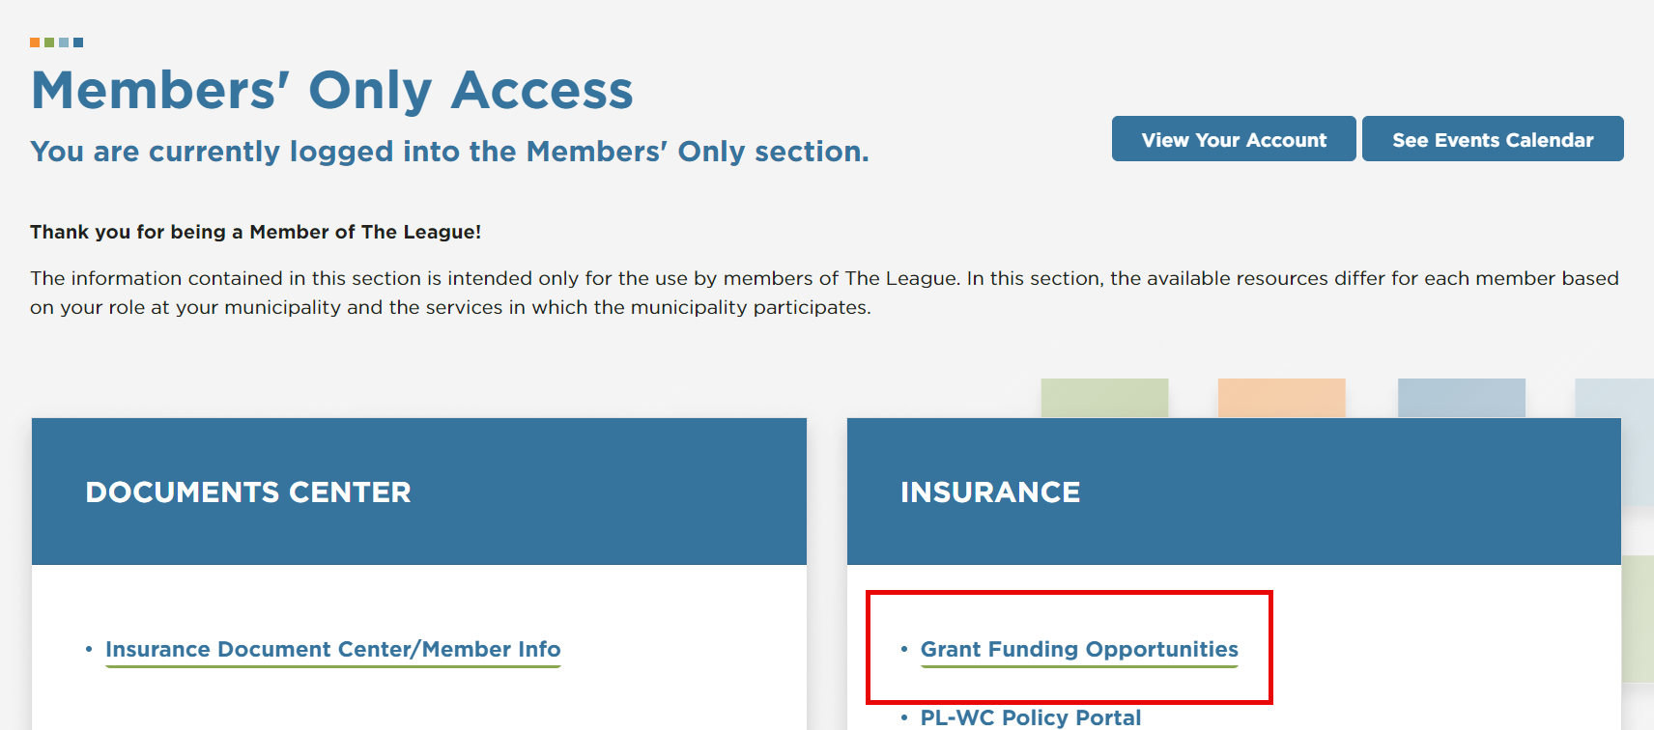
4. You have 2 types of grant applications available online: Safety or Soft-Body Armor. Each secion has a link to the appropriate application.  
   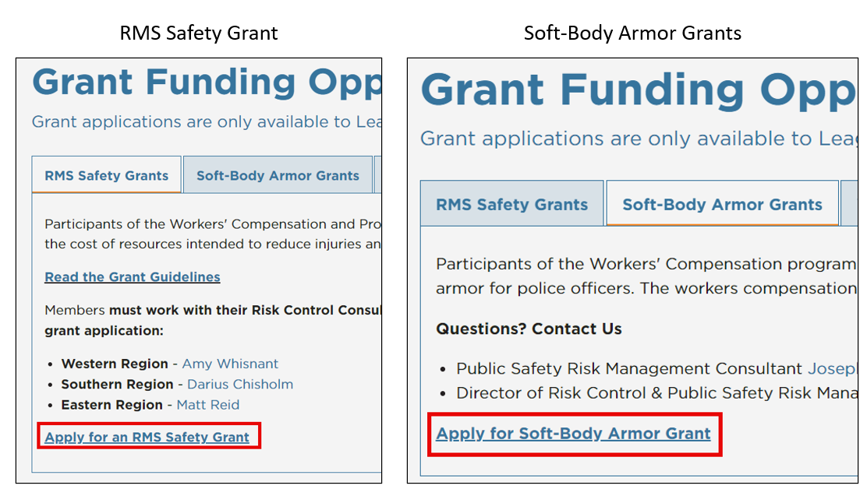
5. Pick the appropriate grant type (Soft-Body Armor, Safety, Emergency Management) and click the corresponding button shown below:  
   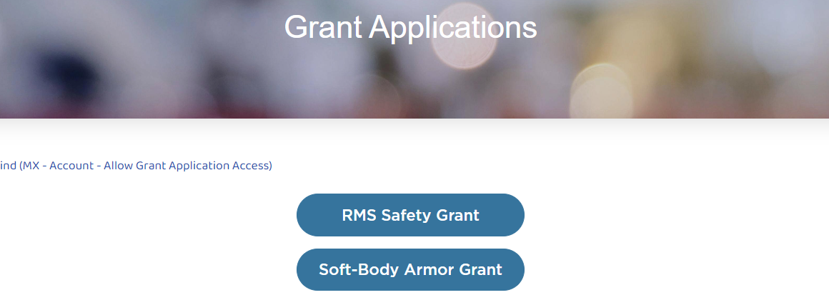
6. This will take you into the actual application. Follow all the steps to submit your grant application for review.
7. Update the Grant Request Type question if the header is for the wrong grant type.
8. Attach invoices, policies, manager signatures, and other documentation.
9. For Safety Grants, you may add multiple items to the grant request for funding.
10. Press the Submit button once complete. You can no longer change grant request types.