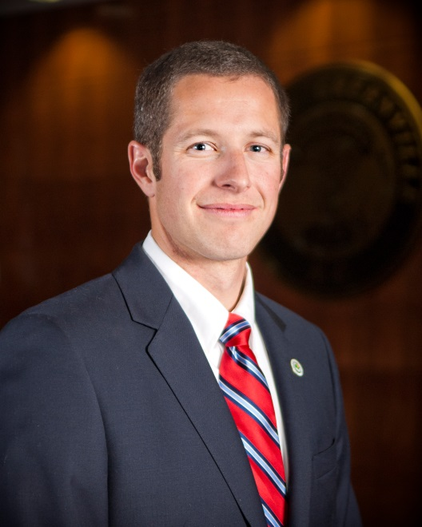Mayor P.J. Connelly is a public leader dedicated to seeing Greenville flourish and committed to acting as a responsible steward of the public’s trust. Mayor Connelly first joined the Greenville community in 2004 as a standout member of East Carolina University’s baseball team. He graduated in 2005 with degree in Finance and went on to play professional baseball with the Los Angeles Angels before returning to Greenville in 2007 to open his own real estate business and start a family. He married Jaclyn Connelly in 2009 and they have two daughters, Mary Kate and Caroline.  Mayor Connelly channeled his passion for his community into public service, volunteering his time as a member of the City of Greenville’s Planning & Zoning Commission, where he weighed in on a number of issues regarding planning regulations and future developments. In 2015, he was elected to the City Council to represent the citizens of District 5. He has served as Mayor since he successfully ran for the role in 2017. Mayor Connelly also represents the City on a number of regional boards and committees, including: the Pitt-Greenville Chamber Board, the Greenville Urban Area Metropolitan Organization (MPO), North Carolina Metropolitan Mayors, North Carolina League of Municipalities (NCLM) Mayors Association, and the NCLM Advancing Municipal Leaders Advisory Council.